Manchester City Council
Role Profile

Tree Officer (Arboriculture), Grade 7
Grounds Technical Service, Neighbourhoods Directorate
Reports to: Senior Tree Officer Grounds Technical
Job Family: Front-Line Delivery

Key Role Descriptors:

The role holder will undertake a lead role in a professional, customer focused, specialist technical service which enables the delivery of organisational objectives and provides a high-quality service to customers in line with internal guidelines, policies and procedures and statutory requirements.

The role holder will lead the delivery of a range of technical projects, initiatives or work packages that comply with relevant legislation and help achieve the Council’s corporate aims and objectives

The role holder will provide specialist technical consultancy across the assigned service area to develop, design and implement customer-focused solutions for the assigned service area. They will act as a key member of the team and will ensure high standards of customer service and service delivery.

Key Role Accountabilities:

Provide an effective technical consultancy function for the assigned service area, ensuring that high quality technical solutions are delivered in line with customer or legislative requirements. Dependent on the service area, this may include software / information technology support, engineering, surveying, curating or other specialist functions.

Lead on the delivery of work packages (using project management methodology where appropriate) so that objectives are achieved, ensuring consistency in approach and compliance with appropriate internal and legislative guidelines.

Develop successful relationships and secure stakeholder commitment through negotiation and communications, both oral and written, to ensure work packages are delivered effectively and to customer requirements and agreed objectives. This will include the communication of complex technical matters.

Ensure all work carried out fits within the parameters of service level agreements, using appropriate specialist equipment / software or tools where required, in line with safe working practices and health and safety regulations.

Represent the City Council as an expert witness at enquiries, tribunals and hearings or similar proceedings where appropriate.

Roles at this level may be required to manage a range of assigned resources, which may be human, financial or other, to ensure continuous improvement in service delivery. Staff management duties may be either through direct line management of a team (including appraisals, performance management and other duties) or through matrix management of a virtual team of officers. The role holder will be expected to effectively co-ordinate resources to support the principals of ‘joined up’ communication and to ensure efficiencies are achieved.

Dependent on the service area, the role holder may be required to work on a rota basis including out of hours as required to meet customer demand.

Demonstrate a personal commitment to continuous self-development and service improvement.

Through personal example, open commitment and clear action, ensure diversity is positively valued, resulting in equal access and treatment in employment, service delivery and communications.

Where the role holder is disabled, every effort will be made to supply all necessary aids, adaptations or equipment to allow them to carry out all the duties of the role. If, however, a certain task proves to be unachievable, job redesign will be fully considered.

Role Portfolio:
The Neighbourhood’s Service is an integrated model for the delivery of neighbourhood services that combines Citywide Services providing strategic direction and operational management of services together with specialist technical support, and 3 Neighbourhood based teams where the services are delivered.
The purpose of the Neighbourhoods Service model is to effectively realise Manchester's vision and outcomes for neighbourhoods that are key to the delivery of the new Manchester Strategy. The vision is for clean, safe, and green neighbourhoods where people choose to live, with access to employment opportunities and a high-quality sport, leisure, and cultural offer. Neighbourhoods should be places where communities are engaged and have an increased sense of pride with positive perceptions of the area, and social and volunteering opportunities. The purpose of the Neighbourhoods Service is described below.
The services within the scope of Grounds Technical includes the management and development of Manchester’s public realm and greenspace through improving and enhancing existing grounds maintenance approaches whilst at the same time exploring and developing alternative approaches to help enhance nature and beautify the city for example by developing new delivery arrangements for Climate Change and Biodiversity Gain targets via partners across all sectors.
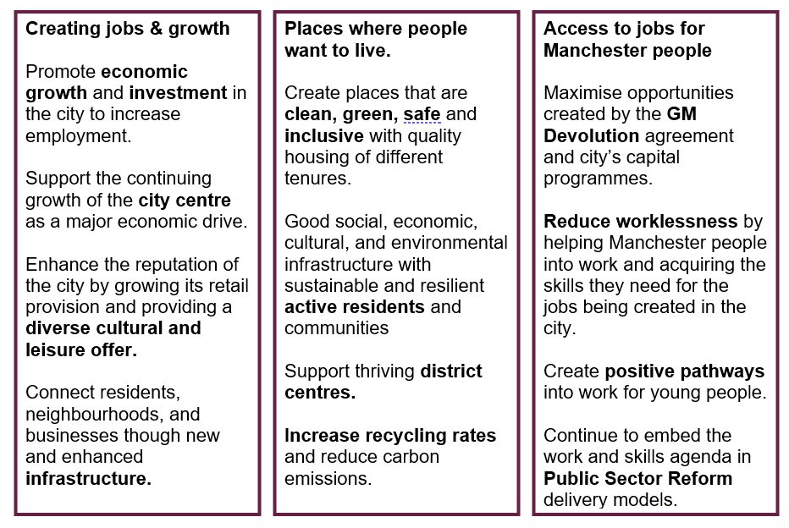

About the role:

A tree Officer role necessitates a conscientious individual with a meticulous eye for detail and a proven track-record with an in-depth understanding in arboriculture, with a passion for preserving Manchester’s unique arboreal landscape and a good knowledge of GIS based tree management systems to capture precise records and ensure safety.

Confidently engage with a wide range of stakeholders, including the public, council colleagues, and private sector partners, and an ability to unite teams and foster partnerships is pivotal.
.
The role requires regular site visits, clear communication and an alignment with Our Manchester Behaviours ensuring the city remains a vibrant, green, and sustainable place to live and work.

Key Behaviours, Skills and Technical Requirements

Our Manchester Behaviours
- We are proud and passionate about Manchester
- We take time to listen and understand
- We ‘own it’ and we’re not afraid to try new things
- We work together and trust each other
- We show that we value our differences and treat people fairly

Generic Skills

1: Communication Skills - Ability to advise and put case across in relatively straightforward, non-contentious situations with ability to negotiate agreements.

2: Analytical Skills - Ability to identify patterns and trends that may impact on decisions and propose realistic conclusions identifying the risks and any assumptions made.

3: Planning and Organising - Demonstrate excellent judgement skills under competing priorities and pressure

4: Problem Solving and Decision Making - Ability to react to immediate problems of a highly complex nature with associated risk factors and deliver pragmatic solutions sometimes under extreme pressure.

5: Creative Skills - Ability to think creatively to proactively potential future scenario’s and to develop a range of creative solutions that meet the strategic needs of the business and are new and original.

6: Research and Intelligence - Ability to analyse and present evidenced based information from a variety of different sources, often conflicting, using established research methodology.

Technical Requirements (Role Specific)

- The Royal Forestry Society (RFS) Certificate in Arboriculture Level 4 Certificate
- NPTC (0039-36) Tree work Planning
- Quantified Tree Risk Assessment (QTRA) Practitioner,
- City & Guilds NPTC Level 2 Award: C30/31 Maintain chainsaw and fell small tree

Applicants must hold a Full and current UK Driving Licence

